Title of the article times new roman, font size 14, bold, small letters, align to centre, maximum of two lines

Name1 Surname1 (maximum of five authors without diacritics)
The first author's full address, institution name, address, e-mail (corresponding author)
Name2 Surname2
The second author's full address, institution name, address, e-mail
Name3 Surname3
The third author's full address, institution name, address, e-mail
Name4 Surname4
The fourth author's full address, institution name, address, e-mail
Name5 Surname5
The fifth author's full address, institution name, address, e-mail

Keywords: significant for identification of the article 5 keywords maximum.
Abstract: The keywords should be arranged in a hierarchical order, e.g., measurement, complex technological systems, etc. Please note that the abstract is one of the most important parts of scientific papers. The abstract represents a shortened form of the whole article. The abstract should begin with the article's goal and definition of the solved problem up to the main results and findings, the abstract consists of 250 words maximum. The abstract font is Times New Roman. Font size is 10 pt., align is justified. The journal Acta Simulatio mainly accepts the articles' IMRAD (Introduction, Methods, Results, and Discussion) scientific structure.

Introduction
The text of the article is font type Times New Roman. Font size is 10 pt., align is justified with the first line indent of 0.5 cm. The main text of the article is positioned in two columns. The line spacing is 1.0 (simple) throughout the template.
The article should be compiled in the following order: title page; keywords; abstract; main text; conclusions; acknowledgements; references.
Papers submitted to Acta Simulatio must be based on original theoretical or experimental investigations. The publisher takes no responsibility for injury and/or damage to persons or property resulting from a matter of product liability, negligence or otherwise, or from any use or operation according to any methods, products, instructions or ideas contained in the material published herein. All advertising material is expected to conform to ethical standards. Its inclusion in this publication does not guarantee or endorse the value of such products or its manufacturer's claims.
The length of the article must be from 4 (minimum) to 12 (maximum) pages [1,2]. The article must be saved in Microsoft Word as .doc or .docx form and sent by e-mail with pdf file too.
In the article, it is necessary to use English spelling and punctuation. In addition, authors must adhere to regular S.I. units [3-7].
The figure format can be colour or greyscale in the best quality possible. The figure must be readable and font type Times New Roman, font size 10 (9). Figures are located directly into the text and centred [2,8-10]. All figures must be numbered in the order they appear on the paper (Figure 1).
Numbering and a description of figures are performed below the figures, e.g., Times New Roman, 9 pt., Italic, centred.

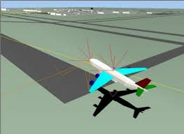
Figure 1 Simulation of the aeroplane fly

The second level heading 11 pt., left, italic
The table format can be in colour or greyscale in the best quality. Text in the table must be readable with font type Times New Roman, font size 10 (9). Tables are located directly into the text and centred [1,3,11,12]. All tables must be numbered in the order in which they appear on the paper (e.g., Table 1, Table 2, …). Numbering and description of the tables are performed above the tables, Times New Roman, 9 pt., Italic, centred.

Table 1 Matrix of length
 | A | B | C | D | E | F
A | 0 | 2 | 5 | 8 | 6 | 5
B | 9 | 0 | 3 | 6 | 4 | 1
C | 6 | 2 | 0 | 5 | 2 | 1
D | 32 | 4 | 6 | 0 | 1 | 0
E | 4 | 7 | 1 | 2 | 0 | 3
F | 5 | 3 | 4 | 1 | 1 | 0
G | 56 | 18 | 19 | 22 | 14 | 10

Text in equation form must be readable, Cambria Math, font size 10, italic, centred. All equations must be numbered in the order in which they appear in the paper (e.g. (1), (2)). The numbering of equations is performed beside the equation [2-4,13-19].

${\left(x+a\right)}^{n}=\sum_{k=0}^{n}{\left({n \atop k}\right)x^{k}a^{n-k}}$ (1)

Ethical rules
The editorial office may reject manuscripts if it is felt that the work was not carried out within an ethical framework. Plagiarism in any form constitutes a serious violation of the most basic principles of education, research and scholarship and cannot be tolerated. This policy details the responsibilities of all authors, editors and reviewers working with and for Acta Simulatio journal as well as our ethical responsibilities. This includes, but is not limited to, plagiarism, data falsification, misuse of third-party material, fabrication of results and fraudulent authorship [20].

Methodology

Peer review process
After submitting a manuscript, authors will receive information about receipt of the manuscript. All submitted manuscripts for the Acta Simulatio journal are sent out for the peer-review process. The peer-review process takes place in several rounds. In the first round, the manuscripts are reviewed by the journal's editor concerning the quality and focus of the manuscripts. In addition, manuscripts are checked for plagiarism. Manuscripts that are out of the aim and scope do not comply with the plagiarism check of the journal or are of an unacceptably low standard, and quality will be rejected directly without the second-round peer-review process. Each manuscript will be single-blind reviewed by at least two reviewers. The review process will take time no more than 2 months. The reviewers will fill out a review form and evaluate the submitted manuscripts. Reviewers will evaluate the following points:
- The manuscript is relevant for the Acta Simulatio journal.
- The manuscript is new, interesting, original and high quality.
- The manuscript is prepared clearly, logically and correctly.
- The language of the manuscript is clear and understandable.
- The manuscript's figures, diagrams, charts, and tables are readable, clear, and high-quality.
- References of the manuscript are used correctly.

The review process continues to notify authors if the manuscript can be accepted without modification, received after modification or rejected. The review process ends with checking the final pdf article version and confirming the article for publication in the journal by the authors (if the editor and reviewers accepted the manuscript for publishing). The journal's editor has the right to manage and, in certain circumstances, change the peer review process at his discretion [20].

Results and discussion
All in-text citations should be listed in the reference list at the end of your document (Figure 2, Figure 3).
Large images and tables can be placed as (Figure 2, Figure 3, Table 2).

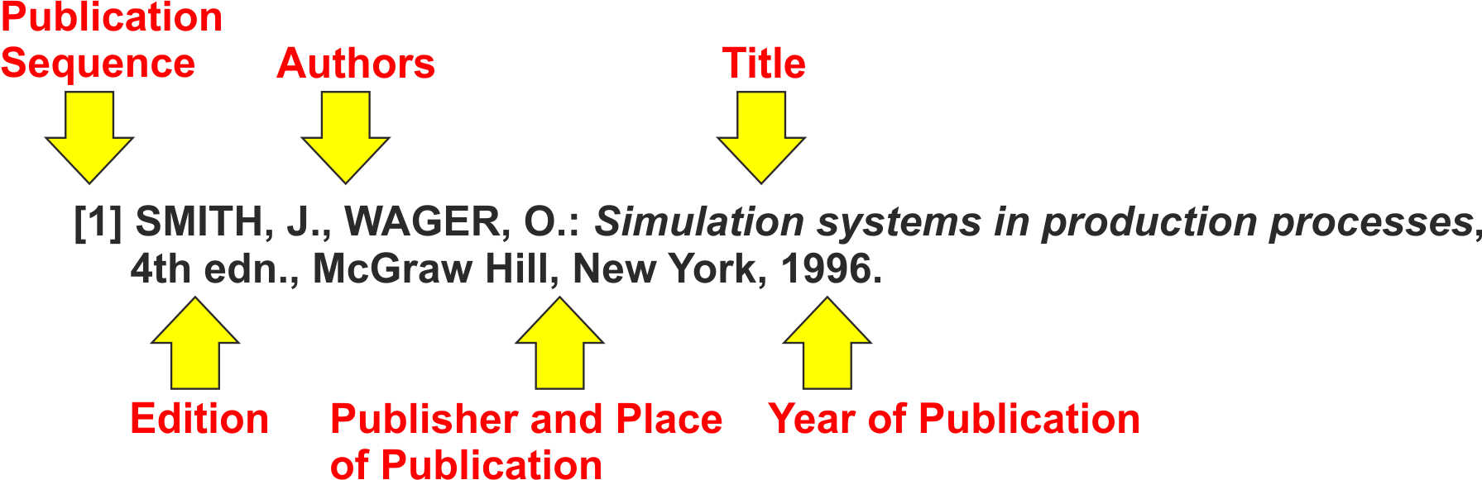
Figure 2 Reference list entry for a book

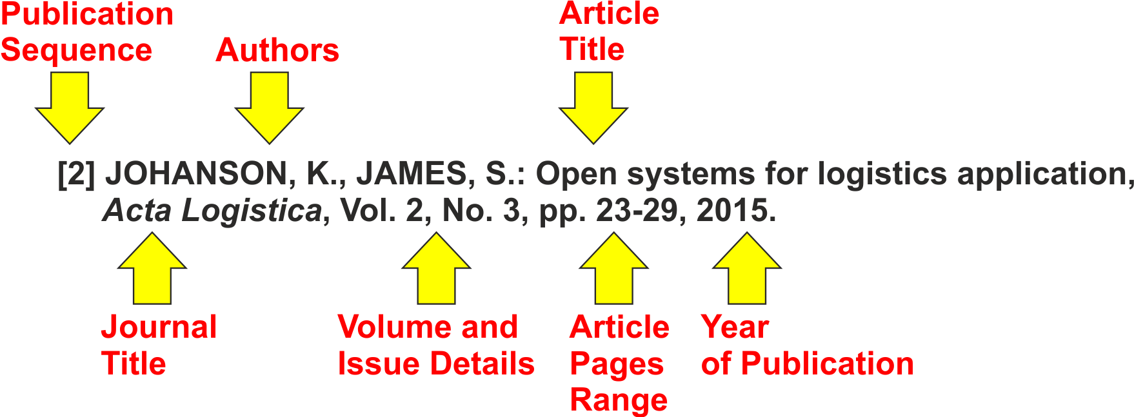
Figure 3 Reference list entry for a journal

Table 2 Matrix of length
 | A | B | C | D | E | F
A | 0 | 2 | 5 | 8 | 6 | 5
B | 9 | 0 | 3 | 6 | 4 | 1
C | 6 | 2 | 0 | 5 | 2 | 1
D | 32 | 4 | 6 | 0 | 1 | 0
E | 4 | 7 | 1 | 2 | 0 | 3
F | 5 | 3 | 4 | 1 | 1 | 0
G | 56 | 18 | 19 | 22 | 14 | 10

References style (Note: If authors have a problem with the preparation of the references list, you can use the online service www.citethisforme.com with citation style IEEE.)

Book with one author
[1] ADAIR, J.: Effective time management, How to save time and spend it wisely, London, Pan Books, 1998. https://doi.org/10555/atec/article….
Book with two authors
[2] MCCARTHY, P., HATCHER, C.: Speaking persuasively, Making the most of your presentations, Sydney, Allen and Unwin, 1996.
Book with three or more authors
[3] FISHER, R., URY, W., PATTON, B.: Getting to yes, Negotiating an agreement without giving in, 2nd edition, London, Century Business, 1991. https://doi.org/10555/atec/article….
Book – second or later edition
[4] BARNES, R.: Successful study for degrees, 2nd edition, London, Routledge, 1995.
Book with an editor
[5] DANAHER, P.: (ed.) Beyond the Ferris wheel, Rockhampton, CQU Press, 1999.
If you have used a chapter in a book written by someone other than the editor
[6] BYRNE, J.: 'Disabilities in tertiary education, in ROWAN, L. AND MCNAMEE, J. (ed.) Voices of a Margin, Rockhampton, CQU Press, 1994.
Books with an anonymous or unknown author
[7] The University Encyclopedia, London: Roydon, Sentences, 1992.
Written course material, distance learning unit material
[8] DHANN, S.: CAE0001LWR Unit 5, Note-taking skills from lectures and readings, Exeter, Department of Lifelong Learning, 2001.
If the author is unknown
[9] Department of Lifelong Learning, CAE0001LWR Unit 5, Note-taking skills from lectures and readings, Exeter, Lecturer, 1999.
Government publications
[10] Department for Education and Employment (DfEE), Skills for life, The national strategy for improving adult literacy and numeracy skills, Nottingham, AfRR Publications, 2001.
Conference papers, Proceedings
[11] HART, G., ALBRECHT, M., BULL, R., MARSHALL, L.: 'Peer consultation: A professional development opportunity for nurses employed in rural settings', Infront Outback – Conference Proceedings, Australian Rural Health Conference, Toowoomba, pp. 203-215, 2010. https://doi.org/10555/atec/article….
Newspaper articles
[12] CUMMING, F.: 'Tax-free savings push', Sunday Mail, 4 April, p. 1, 2005.
If the author is unknown
[13] 'Tax-free savings push', Sunday Mail, 4 April, p. 3, 2001.
Journal article
[14] TREBUNA, P., PETRIKOVÁ, A., PEKARČÍKOVÁ, M.: Influence of physical factors of working environment on worker's performance from the ergonomic point of view, Acta Simulatio, Vol. 3, No. 3, pp. 1-9, 2017. https://doi.org/10555/asim/article
Journal article from CD-ROM, electronic database, or journal
[15] SKARGREN, E.I., OBERG, B.: Predictive factors for the 1-year outcome of low-back and neck pain in patients treated in primary care, Comparison between the treatment strategies chiropractic and physiotherapy, Pain [Electronic], Vol. 77, No. 2, pp. 201-208, Available: Elsevier/ScienceDirect/O304-3959(98)00101-8, [10 March 1999].
Electronic mail (e-mail)
[16] JOHNSTON, R.: Access courses for women, e-mail to NIACE Lifelong Learning Mailing List (lifelong-learning@niace.org.uk), 22 Aug. [24 Aug 2001], 2001.
[17] ROBINSON, T.: Re: Information on course structure, e-mail to S. Dhann (s.dhann@exeter.ac.uk), 12 Jul. [13 Jul 2001], 2001.
Discussion list
[18] BERKOWITZ, P.: Sussy's gravestone, 1993, Mark Twain Forum [Online], 3 Apr, Available e-mail: TWAIN-L@yorkvm2.bitnet [3 Apr 1995].
World Wide Web page
[19] YOUNG, C.: English Heritage position statement on the Valletta Convention, [Online], Available: http://www.archaeol.freeuk.com/EHPostionStatement.htm [24 Aug 2001], 2001.
[20] Acta Simulatio, www.actasimulatio.eu: Instructions for authors, [Online], Available: http://www.actasimulatio.eu/index.php?stranka=forauthors [17 Jan 2022], 2015.

Conclusions
As part of the submission process, authors must check off their submission's compliance with all of the following items, and submission of a manuscript may be returned to authors who do not adhere to these guidelines.
- The manuscript has not been previously published, nor is it before another journal for consideration (or an explanation has been provided in Comments to the Editor).
- Where available, URLs and available DOIs for the references have been provided.
- The manuscript is prepared following the instructions for the authors.
- The text adheres to the stylistic and bibliographic requirements outlined in the author guidelines, found in the "For Authors" folder and the journal template.
- By sending the manuscript for publishing in the journal Acta Simulatio author/authors agree with the terms and conditions defined by Acta Simulatio.
- DOI numbers for identification are appropriate.

Acknowledgement 10 pt, left
The state grant agency supported this article. Please do not put ISSN and ISBNs into references! All references must be in English with the mark of language originality at the end of the reference, e.g. (Original in Slovak, Polish, Russian, …)

References
[1] ADAIR, J.: Effective time management, How to save time and spend it wisely, London, Pan Books, 1998. https://doi.org/10555/atec/article….
[2] MCCARTHY, P., HATCHER, C.: Speaking persuasively, Making the most of your presentations, Sydney, Allen and Unwin, 1996.
[3] FISHER, R., URY, W., PATTON, B.: Getting to yes, Negotiating an agreement without giving in, 2nd edition, London, Century Business, 1991. https://doi.org/10555/al/article….
[4] BARNES, R.: Successful study for degrees, 2nd edition, London, Routledge, 1995.
[5] DANAHER, P.: (ed.) Beyond the Ferris wheel, Rockhampton, CQU Press, 1999.
[6] BYRNE, J.: 'Disabilities in tertiary education, in ROWAN, L. AND MCNAMEE, J. (ed.) Voices of a Margin, Rockhampton, CQU Press, 1994.
[7] The University Encyclopedia, London: Roydon, Sentences, 1992.
[8] DHANN, S.: CAE0001LWR Unit 5, Note-taking skills from lectures and readings, Exeter, Department of Lifelong Learning, 2001.
[9] Department of Lifelong Learning, CAE0001LWR Unit 5, Note-taking skills from lectures and readings, Exeter, Lecturer, 1999.
[10] Department for Education and Employment (DfEE), Skills for life, The national strategy for improving adult literacy and numeracy skills, Nottingham, AfRR Publications, 2001.
[11] HART, G., ALBRECHT, M., BULL, R., MARSHALL, L.: 'Peer consultation: A professional development opportunity for nurses employed in rural settings', Infront Outback – Conference Proceedings, Australian Rural Health Conference, Toowoomba, pp. 203–215, 2010. https://doi.org/10555/al/article….
[12] CUMMING, F.: 'Tax-free savings push', Sunday Mail, 4 April, p. 1, 2005.
[13] 'Tax-free savings push', Sunday Mail, 4 April, p. 3, 2001.
[14] TREBUNA, P., PETRIKOVÁ, A., PEKARČÍKOVÁ, M.: Influence of physical factors of working environment on worker's performance from the ergonomic point of view, Acta Simulatio, Vol. 3, No. 3, pp. 1-9, 2017. https://doi.org/10555/asim/article
[15] SKARGREN, E.I., OBERG, B.: Predictive factors for the 1-year outcome of low-back and neck pain in patients treated in primary care, Comparison between the treatment strategies chiropractic and physiotherapy, Pain [Electronic], Vol. 77, No. 2, pp. 201-208, Available: Elsevier/ScienceDirect/O304-3959(98)00101-8, [10 March 1999].
[16] JOHNSTON, R.: Access courses for women, e-mail to NIACE Lifelong Learning Mailing List (lifelong-learning@niace.org.uk), 22 Aug. [24 Aug 2001], 2001.
[17] ROBINSON, T.: Re: Information on course structure, e-mail to S. Dhann (s.dhann@exeter.ac.uk), 12 Jul. [13 Jul 2001], 2001.
[18] BERKOWITZ, P.: Sussy's gravestone, 1993, Mark Twain Forum [Online], 3 Apr, Available e-mail: TWAIN-L@yorkvm2.bitnet [3 Apr 1995].
[19] YOUNG, C.: English Heritage position statement on the Valletta Convention, [Online], Available: http://www.archaeol.freeuk.com/EHPostionStatement.htm [24 Aug 2001], 2001.
[20] Acta Simulatio, www.actasimulatio.eu: Instructions for authors, [Online], Available: http://www.actasimulatio.eu/index.php?stranka=forauthors [17 Jan 2022], 2015.

